Auto Marine Professionals

Content Marketing Strategy Proposal

Taryn Carroll


“Your 5-star Service Professionals”

Auto Marine Professionals is a small business in the heart of Marsh Harbour, Abaco that has big dreams in fulfilling the community’s needs. Auto Marine Professionals is known for their hardworking mechanics, 5-star service, and reliability. By setting up a blog styles website, Auto Marine Professionals would not only be guaranteed more business, but it could also take less stress off of the companies shoulders by having all of the basic information about your business online in order to educate your customers. By adding a signature story to website, your customers would know where this company started and who was involved, thus providing a stronger relationship with your customers.

Overview

Auto Marine Professionals is a small business in the heart of Marsh Harbour, Abaco that has big dreams in fulfilling the community’s needs. Auto Marine Professionals understands that there are some troubles that can come about with cars, especially on a small island where it’s hard to keep car parts available, and because of this, Auto Marine Professionals prides itself on their reliability to the community.

Strengths

Auto Marine Professionals’ strength is how reliable the company has always been, even after a catastrophic hurricane. Due to the reliability, customers have a better relationship with the company because they feel that they have someone they can depend on. Auto Marine Professionals also is the only car shop in the area that provides a long list of services for cars and constantly evolves to fit the demand of customers. While other businesses in the area may provide similar services, Auto Marine Professionals ensures that vehicles will be returned with the problem solved and with the best equipment used in the process. Lastly, AMP keeps an open communication with their customers throughout the process so that customers feel comfortable bringing their car back in case a problem arises.

Weaknesses

As of right now, Auto Marine Professionals does not have a website and hasn’t been active on any social media accounts in order to promote their services. In order to have a better relationship with the customers, it would be best to begin posting on social media more frequently, but also having a website that people can access even when business hours are over. This will not only allow the brand to grow bigger, but also give customers a space where they can have any frequently asked questions answered without going through the trouble of calling the business.

Opportunities

Auto Marine Professionals is going through some big changes right now with a new garage being built, with this new garage comes many possibilities. With the new garage adding more technology, the company can benefit from an online content marketing campaign in order to keep their customers more involved and excited. By adding a signature story to a blog style website, customers will be able to see how far along the business has grown since opening its doors compared to the new state of the art building that is on its way. By adding more pictures to the Facebook page, customers can be more involved in the work that goes on behind the office and see the behind the scenes of all of the work that goes into fixing their car. When adding a FAQ section into the website, we can promote businesses by telling customers how often they should have their car serviced, and what are some warning signs in a vehicle.

Goals

These are the following goals that have been set for Auto Marine Professionals’ content marketing campaign. This campaign is planned to begin on December 1, 2022 and the goals could be achieved by December 1, 2023. The goals set are as follows:
- Promote the services being offered at Auto Marine Professionals
- Provide customers with easy access to frequently asked questions
- Increase the demand of Auto Marine Professionals in Abaco

Target Audience

The target audience for this campaign is owners of big machinery that need hose replacements and any car owners in the area that would benefit from the high-quality work being done by Auto Marine Professionals.

Big Machinery

Hose replacements for big machinery has increased in the hurricane in 2019, thus big machinery needing a bigger supply of replacement hoses. Auto Marine Professionals has been the stop for these hoses, but by promoting this in the campaign, this service can provide a bigger name for itself. This service is also one of the least time-consuming services offered by Auto Marine Professionals which can bring in a higher amount profit due to the amount of time that is spent repairing a hose.

Car Owners

The goal of Auto Marine Professionals is to provide high quality to work the average car owner who may not know much about cars. This is the largest audience for this company, thus making it an important target audience in the campaign. Not only will car owners come back for business, but by directing them to the website and having them subscribe to an email subscription, customers will be reminded of when their car should revisit the garage for a general service or maintenance. The relationship with these customers is the one that is depended on the most, by adding these services to the website, it ensures that they’re a returning customer. This not only provides customers with information as to when to bring their car in, but also prevents larger car troubles coming into the shop with more time-consuming projects.

Key Performance Indicators

This content marketing campaign will include several different ways to track the progress of the campaign
- Social Media: Compare the growth of followers and engagement from the older Facebook and Instagram pages to the updated pages as well as keep monthly tracks of the growth with the campaign in place.
- Website Visits: Tracking the number of visits to the website monthly. This will be able to provide statistics on how useful the website has been and see how many customers keep up with the website to find any useful information.

Return on Investment

By increasing the engagement digitally and growing the businesses, this would ensure a return on investment. Sending out monthly email reminders will keep the workflow throughout the garage steady as opposed to having slow and busy seasons during the year.

Scope of Plant

Content Marketing Calendar

Shown below is a content calendar for the month of December 2022. This regulated calendar will be the basis of all of content marketing throughout the year until December 2023. The goal of this strategy is to ensure that Auto Marine Professionals is active on social media, but also allows for new content to be created between certain days.

December 2022

SUN | MON | TUE | WED | THU | FRI | SAT
 |  |  |  | 1  Monthly  Email  Newsletter | 2  Social Media  at 9 a.m. | 3
4 | 5  Social Media  at 9 a.m. | 6 | 7  Knowledge Branding Piece on Website at 5 p.m. | 8 | 9  Social Media  at 9 a.m. | 10
11 | 12  Social Media  at 9 a.m. | 13 | 14 | 15 | 16  Social Media  at 9 a.m. | 17
18 | 19  Social Media  at 9 a.m. | 20 | 21  Knowledge Branding Piece on Website at 5 p.m. | 22 | 23  Social Media  at 9 a.m. | 24
25 | 26  Social Media  at 9 a.m. | 27 | 28 | 29 | 30  Social Media  at 9 a.m. | 31

Samples

Knowledge Branding Content

The knowledge branding content attached below help accomplish the content marketing goal of showing customers all of the services offered by Auto Marine Professionals. Not only does it showcase the services being done, it shows one of the owners of Auto Marine Professionals doing the work in real time, but it also has updated contact information so that customers can reach out to the company.

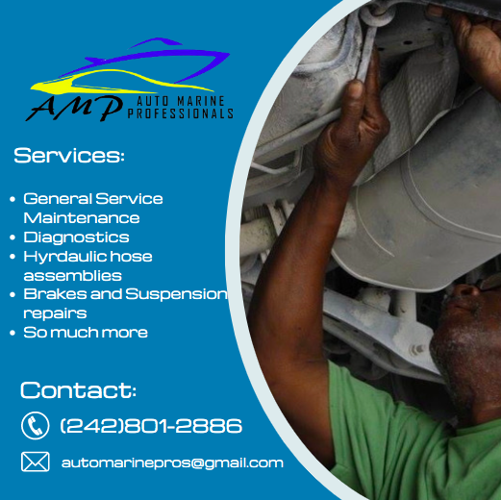

Signature Story Piece

The signature story provides the customer with a look into the beginning of the company and sets aside Auto Marine Professionals from all of the other mechanic shops into the area. It gives the customer a better feel for who the owners of the business are and why they should bring their support to Auto Marine Professionals.

The Story Behind Auto Marine Professionals

Ian Carroll had always had a love for the automotive business but had mostly worked in the marine industry throughout his career. Like most people, he had the dream of working for himself, but he knew that in order for the business to really soar he would have to call upon a few more people. He called upon his previous co-worker, Ken Davis, who knew that this business offer was not one to turn down. Next came his brother-in-law, Ryan Higgs, who had always had a knack for the car business but was looking for something more in his career. They all knew that the Abaco community needed a reputable mechanic shop, but they all wanted something bigger and better for this little Island that didn’t have much going for it.

Well, with a lot of perseverance and patience, Auto Marine Professionals finally opened their doors, but it wasn’t without any bumps in the road. The biggest obstacle was finding a place to rent, somewhere that had enough space for car lifts and yard big enough to hold all of the business that was going to be heading their way. After that came the money, none of them wanted to owe the bank money, so they put in what they had hoping that their dreams could become a reality, and sure enough, it did!

After Hurricane Dorian in 2019, they were one of the first shops to open back up to the public and they knew it was time for an expansion. Thanks to the support from the community and all of the love the customers have for the owners, Auto Marine Professionals now has their new state of the art garage in the works. With the help of a small community, some hard-working hands, and three big dreamers, this small workshop is now growing and providing Abaco with the automotive care they deserve.



Closing Statement

Auto Marine Professionals content marketing campaign will only increase the demand of the business while also keeping customers more informed throughout the process. With the big changes happening in the new year, it is important that Auto Marine Professionals stands out in the best way possible and this campaign will be crucial in allowing that to happen.

My team and I look forward to working with you in the future to provide better communication between you and your customers by increasing engagement in an online presence. It’s time to give your 5-star professionals an outlet to show all of the hard work they put into their job.

